PC Based Home Automation

Our proposed system allows user to automate his/her home appliances through simple mouse clicks. We bring the entire home automation functionality on users PC. User may operate all lights fans easily while working on his/her PC by simply clicking on a user friendly computer application. Here we use serial communication to communicate between the PC and microcontroller based circuit.
The microcontroller is used to receive and decode load switching commands sent through PC serially and then operate loads accordingly. Our system also allows user to get status of loads current status. In this case the pc sends a status request to the microcontroller circuit and the microcontroller then retrieves the load status and sends this data serially to the PC.
The PC application now receives the data and displays the results to the user. Thus this system demonstrates the use of microcontroller based PC home automation system.
Note: This project only works on Computers having Serial communication port, which is usually present in desktop computers not on laptops

Block Diagram:

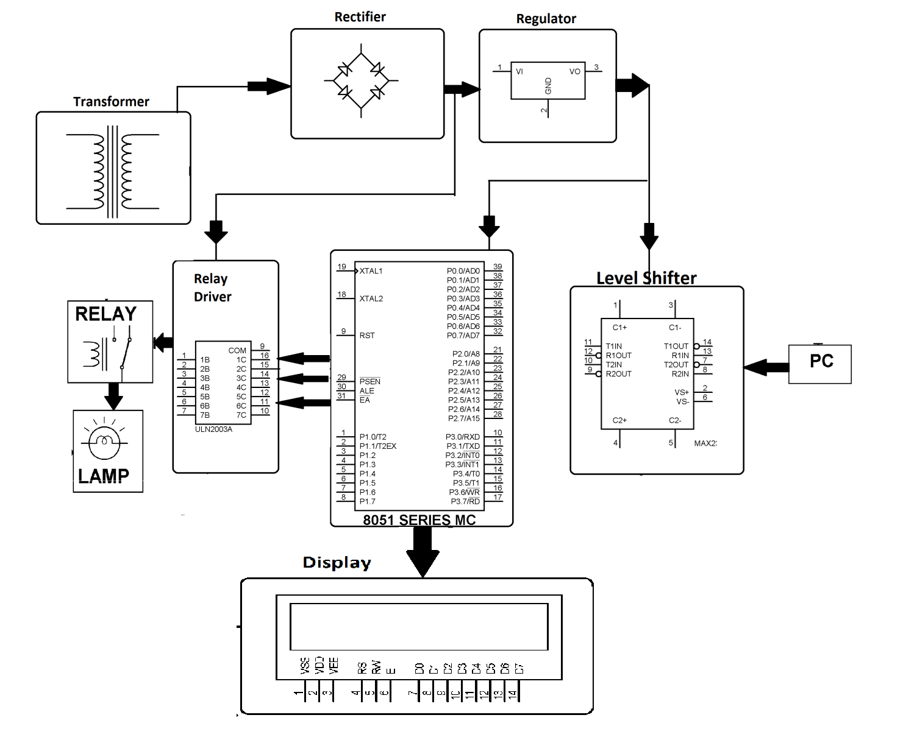

Hardware Specifications
- DB Connector
- 8051 series Microcontroller
- Relays
- LED
- Relay Driver
- Lamps
- Transformer
- Diodes
- Crystal
- Level Shifter IC

Software Specifications
- Keil µVision IDE
- Programming language: C
- MC Programming Language: Embedded C

